**DOKUMENTASI PERANCANGAN API SISTEM YAVA**

Tools :

* NodeJs (bahasa pemrograman)
* ExpressJs (framework)
* PostgreSQL 9.3.24 (database)
* Postman (tester API)

Functions :

* viewCluster

http://localhost/api/cluster/:cluster_name

Contoh : <http://localhost:3000/api/cluster/cluster002>

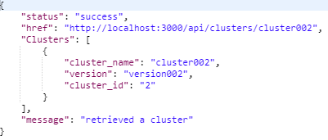

* createCluster

http://localhost/api/cluster

Contoh : [http://localhost:3000/api/cluster](http://localhost:3000/api/cluster/cluster002)



* editCluster

http://localhost/api/cluster/:cluster_id

Contoh : <http://localhost:3000/api/cluster/2>



* deleteCluster

http://localhost/api/cluster/:cluster_id

Contoh : <http://localhost:3000/api/cluster/2>



* getCpu (mengambil data cpu usage)

<http://localhost/api/cpusage>

Contoh : <http://localhost:3000/api/cpusage>



* getDisk (mengambil data diskspace)

<http://localhost/api/diskspace>

Contoh : <http://localhost:3000/api/diskspace>

